ORDINANCE NO. 2024-34
CPA 22-06

RE-ADOPTION OF AN ORDINANCE OF THE CITY OF NEWBERRY, FLORIDA, FOR A LARGE-SCALE LOCAL LAND USE PLAN AMENDMENT TO ORDINANCE NO. 4-91, AS AMENDED, RELATING TO AN AMENDMENT TO THE FUTURE LAND USE PLAN MAP OF THE CITY OF NEWBERRY COMPREHENSIVE PLAN, IN ACCORDANCE WITH SECTIONS 163.3161 THROUGH 163.3215, FLORIDA STATUTES; PROVIDING FOR A CHANGE IN FUTURE LAND USE CLASSIFICATION FROM “AGRICULTURE” TO “RESIDENTIAL LOW DENSITY” ON CERTAIN LANDS CONSISTING OF 250 ACRES, MORE OR LESS, WITHIN THE CORPORATE LIMITS OF THE CITY OF NEWBERRY, FLORIDA MORE PARTICULARLY DESCRIBED IN EXHIBIT “A” ATTACHED HERETO; AUTHORIZING TRANSMITTAL OF THE LARGE-SCALE LAND USE MAP AMENDMENT TO THE FLORIDA DEPARTMENT OF COMMERCE; PROVIDING FOR AMENDMENT TO THE LAND USE PLAN; PROVIDING SEVERABILITY; REPEALING ALL ORDINANCES IN CONFLICT; AND PROVIDING AN EFFECTIVE DATE.

WHEREAS, Section 166.021, Florida Statutes, empowers the City Commission of the City of Newberry, Florida, hereinafter referred to as the City Commission, to prepare, adopt and implement a Comprehensive Plan;

WHEREAS, Sections 163.3161 through 163.3215, Florida Statutes, the Local
Government Comprehensive Planning and Land Development Regulation Act, empowers and requires the City Commission to prepare, adopt and implement a Comprehensive Plan;

WHEREAS, an application, CPA 22-06, for an amendment for lands described in Exhibit “A” attached hereto, to the Future Land Use Plan Map of the City of Newberry Comprehensive Plan, hereinafter referred to as the City's Comprehensive Plan has been filed with the City;

WHEREAS, the Planning and Zoning Board of the City of Newberry, Florida, hereinafter referred to as the Planning and Zoning Board, has been designated as the City of Newberry Local Planning Agency, hereinafter referred to as the Local Planning Agency;

WHEREAS, pursuant to Section 163.3174, Florida Statutes, and Ordinance No. 9-92, as amended, entitled City of Newberry Land Development Regulations, hereinafter referred to as the City's Land Development Regulations, the Planning and Zoning Board, serving also as the Local Planning Agency, held the required public hearing, with public notice having been provided, on said application for an amendment, as described below, to the Future Land Use Plan Map of the City's Comprehensive Plan, and, at said public hearing, the Planning and Zoning Board, serving also as the Local Planning Agency, reviewed and considered all comments received during said public hearing concerning said application for an amendment, as described below, to the Future Land Use Plan Map of the City's Comprehensive Plan and recommended to the City Commission approval of said application for amendment, as described below, to the Future Land Use Plan Map of the City's Comprehensive Plan;

WHEREAS, the City Commission held two public hearings, with public notice having been provided, under the provisions of the regular amendment public hearing procedures established in Sections 163.3161 to 163.3215, Florida Statutes, on said application for amendment, as described below, to the Future Land Use Plan Map of the City's Comprehensive Plan and at said public hearings, the City Commission reviewed and considered all comments received during said public hearings, including the recommendation of the Planning and Zoning Board, serving also as the Local Planning Agency;

WHEREAS, the City Commission found said application for an amendment, as described below, to the Future Land Use Plan Map of the City’s Comprehensive Plan to be compatible with the Land Use Element objectives and policies, and those of other affected elements of the City’s Comprehensive Plan and authorized transmittal to the Florida Department of Commerce, hereinafter “FDOC”;

WHEREAS, the proposed large-scale land use amendment was received by the FDOC, assigned File No. 22-07ESR, was reviewed and found to not have adverse impacts on State of Florida resources, see Exhibit C;

WHERAS, the City Commission held an adoption hearing on October 9, 2023, and transmitted the adopted Ordinance 2023-29, see Exhibit “B,” to FDOC on April 4, 2024;

WHEREAS, pursuant to Section 163.3184, Florida Statutes as amended, the City was unable to transmit the adopted large-scale land use amendment to FDOC within the 10 working days allotted to local governments;

WHEREAS, the City has requested from and been granted an extension by FDOC to comply with Section 163.3184 by October 31, 2024, see Exhibit “D”;

WHEREAS, the City Commission, found, subsequent to the expedited submittal to the Florida Department of Economic Opportunity pursuant to the Expedited State Review Process provided in Section 163.3184 (3), Florida Statutes, no objections recommendations or comments were submitted by said Department and that said application for an amendment, as described below, to the Future Land Use Element of the City’s Comprehensive Plan to be found by the State Land Planning Agency to be compatible with the other affected elements of the City’s Comprehensive Plan; and

WHEREAS, the City Commission, has determined and found that approval of an application for amendment to the Future Land Use Plan Map of the City’s Comprehensive Plan, would promote the public health, safety, morals, order, comfort, convenience, appearance, prosperity or general welfare.

NOW, THEREFORE, BE IT ORDAINED BY THE PEOPLE OF THE CITY OF NEWBERRY, FLORIDA, AS FOLLOWS:

Section 1. Future Land Use Map Amended. Pursuant to an application, CPA 22-06, an application by Paul Kevin Coleman and Tammy Coleman, as equal tenants in common, in reference to Parcel Nos. 02508-002-000, 02522-000-000 and 02514-000-000, Austin Mattox, Emma Mattox and David Mattox in reference to Parcel Nos. 02359-001-000 and 02523-001-001, and M3 Westone Land, LLC, in reference to Parcel Nos. 01981-001-001, 02538-004-002, 02538-004-001, 02538-006-002, 02538-006-000, and 02538-000-000, collectively “Owners,” to amend the Future Land Use Plan Map of the City of Newberry Comprehensive Plan by changing the Future Land Use Classification of certain lands totaling ±250 acres, the Future Land Use classification is hereby changed from AGRICULTURE to RESIDENTIAL LOW DENSITY, on property more particularly described in Exhibit “A” attached hereto.

Section 2. Transmittal. The City Manager or their designee is directed to transmit a copy of this Ordinance to the FDOC within 10 days from the date of re-adoption as required under the Large-Scale amendment process provided in Fs. 163.3184, as amended.

Section 3. Severability. If any provision or portion of this Ordinance is declared by any court of competent jurisdiction to be void, unconstitutional or unenforceable, then all remaining provisions and portions of this Ordinance shall remain in full force and effect.

Section 4. Conflict. All ordinances or parts of ordinances in conflict herewith are, to the extent of such conflict, hereby repealed.

Section 5. Effective Date. This ordinance shall become effective upon adoption. The effective date of this plan amendment shall be the date a final order is issued by the FDOC or Administration Commission finding the amendment in compliance in accordance with Section 163.3184, Florida Statutes, whichever occurs earlier. No development orders, development permits or land uses dependent on this amendment may be issued or commence before it has become effective. If a final order of noncompliance is issued, this amendment may nevertheless be made effective by adoption of a resolution affirming its effective status, a copy of which resolution shall be sent to the Department of Economic Opportunity, Division of Community Planning and Development, 107 East Madison Street, MSC-160, Tallahassee, FL 32399-4120.

Section 6. Authority. This Ordinance is adopted pursuant to the authority granted by Section 166.021 and Sections 163.3161 through 163.3215, Florida Statutes.

DONE, THE FIRST READING, by the City Commission of the City of Newberry, Florida, at a regular meeting the 14th day of October, 2024.

[REMAINDER OF THIS PAGE INTENTIONALLY LEFT BLANK.]

DONE, THE PUBLIC NOTICE, in a newspaper of general circulation in the City of Newberry, Florida, by the City Clerk of the City of Newberry, Florida on the 10th day of October, 2024.

DONE THE SECOND READING, AND ADOPTED ON FINAL PASSAGE, by an affirmative vote of a majority of a quorum present of the City Commission of the City of Newberry, Florida, at a regular meeting, this 28th day of October, 2024.

BY THE MAYOR OF THE CITY OF NEWBERRY, FLORIDA

____________________________________ Honorable Jordan Marlowe, Mayor

ATTEST, BY THE CLERK OF THE
CITY COMMISSION OF THE CITY OF
NEWBERRY, FLORIDA:

____________________________
Judy S. Rice, City Clerk

APPROVED AS TO FORM AND LEGALITY:

____________________________
City Attorney’s Office

EXHIBIT “A”
LEGAL DESCRIPTION

Alachua County Parcel Identification Numbers (“PIN”) 02514-000-000, 02508-002-000, 02522-000-000, 02523-001-000, 02523-001-001, 02538-004-001, 02538-004-002, 02538-006-000, 02538-006-002, LESS AND EXCEPT the portion of 01981-001-001; ±250 acres.

Parcel 1, PIN 02514-000-000
Instrument No. 2326626, ACPR:

The Southeast Quarter of the Southeast Quarter (SE 1/4 of SE 1/4), the Southwest Quarter of the Southeast Quarter (SW 1/4 of SE 1/4); the Southeast Quarter of the Southwest Quarter (SE 1/4 of SW 1/4), the South 210 feet of the Northwest Quarter of the Southeast Quarter (NW 1/4 of SE 1/4) and the South 210 feet of the Northeast Quarter of the Southwest Quarter (NE l/4 of SW 1/4) of Section Five (5), Township Ten (10) South, Range Seventeen {17) East, Alachua County, Florida.

LESS and EXCEPT the following:

1. The right of way for County Road No. 337 (SW 2661" Street) along the East line of the
Southeast Quarter of the Southeast Quarter (SE 1/4 of SB 1/4);
2. Land described in Deed to Albert Charles Crocker in O.R. Book 1444, Page 174;

3. Land described in Deed to Albert Charles Crocker in O.R. Book 1444, Page 176;

4. Land described in Deed to Mary Lee Willis Lee in O.R. Book 1725, Page 2275;

5. Land described in Deed to Donald Amett Willis in O.R. Book 1725, Page 2307;

6. Land described in Deed to Ron Dell Willis and Deborah Doreen Willis, his wife, in O.R. Book 1765, Page 2355;
7. Land described in Deed to Jimerison Clark Crocker in 0.R Book 1914, page 1964;
8. Land described in Deed to Albert C. Crocker in O.R. Book 1914, Page 1967;

9. Land described in Deed to Donald Arnett Willis in O.R. Book 2082, Page 807;

All lying and being in Alachua County, Florida.

Parcel 2, PIN 02508-002-000
Instrument No. 2829280, ACPR:

A tract of land situated in the Southeast 1/4 of Section 5, Township 10 South, Range 17 East, Alachua County Florida, said tract of land being more particularly described as follows:

Commence at the Northwest corner of the Southeast 1/4 of the aforementioned Section 5, Township 10 South, Range 17 East, for a point of reference; thence run South 01°26'03" East, along the West line of said Southeast 1/4 of Section 5, 56.26 feet to the Southerly right ofway line of State Road No. 26 (100 foot right of way), and the point of beginning; thence run South 88°21'07" East, along said right of way line, 369.57 feet: thence run South 01°26'03" East, parallel to the West line of the Northwest 1/4 of the Southeast 1/4 of Section 5, 1075.85 feet to the North line of the South
210.00 feet of said Northwest 1/4 of the Southeast 1/4 of Section 5; thence run South 88°42'30" West, along said North line of the South 210.00 feet of the Northwest 1/4 of the Southeast 1/4 of Section 5, 369.08 feet to the West line of the Northwest 1/4 of the Southeast 1/4 of Section 5: thence run North 01°26'03" West along said West line of the Northwest 1/4 of the Southeast 1/4 of Section 5, 1101.24 feet to the point of beginning.

Parcel 3, PIN 02522-000-000
Instrument No. 2326525, ACPR:

THE NORTHWEST QUARTER OF THE NORTHWEST QUARTER (NW 1/4 OF NW 1/4) OF SECTION 8, TOWNSHIP 10 SOUTH, RANGE 17 EAST, ALACHUA COUNTY, FLORIDA.

Parcel 4 & 5, PINs 02523-001-000 and -001
Instrument No. 3343124, ACPR:

The East 1/2 of the Northwest ¼ Less the East 12.5 acres of the Northwest ¼ of the Northwest ¼ of Section 8, Township 10 South, Range 17 East, Alachua County, Florida.

Together with a non-exclusive perpetual easement for ingress and egress over the North 50 feet of the East 12.5 acres of the Northeast ¼ of the Northwest ¼ and over the North 50 feet of the West¼ of the Northwest¼ of the Northeast¼ of Section 8, Township 10 South, Range 17 East, Alachua County, Florida.

Also, together with easement rights contained in Grant of Easement recorded in Official Records Book 894, Page 587 of the Public Records of Alachua County, Florida.

ALSO

The Southeast ¼ of the Northwest ¼ of Section 8, Township 10 South, Range 17 East, Alachua County, Florida.

Parcel 6, PIN 02538-004-001
Instrument No. 3283629, ACPR:

Tract 3: (James)

That part of Castle Heights Subdivision, as per Plat thereof recorded in Plat Book "B ': Page 11, of the Public Records of Alachua County, Florida, lying in Section 9, Township 10 South, Range 17 East, Alachua County, Florida, being more particularly described as follows:

Commence at a railroad spike on the centerline of County Road No. C-337 marking the Northwest corner of Section 9, Township 10 South, Range 17 East, and thence run N 89°40'44" E, along the North line of said Section 9, a distance of 50.00 feet to an iron rod and cap (PSM 4929) on the East right of way line of County Road No. C-337 and the Point of Beginning; thence run S 00°39'11" E, along said right of way line, a distance of 490.17 feet to a concrete monument (PSM 2001); thence run N 89°40'18" E, a distance of 192.23 feet to an iron rod and cap(PSM 4929), on the West right of way line of Magnolia Avenue; thence run N 00°41'09" W, along said right of way line and a Northerly extension thereof, a distance of 74.96 feet to an iron rod and cap(PSM 4929); thence run N 89°40'18" E, a distance of 1077.32 feet to an iron rod and cap(PSM 4929), on the East line of the Northwest 1/4 of the Northwest 1/4, Section 9, Township 10 South, Range 17 East; thence run N 00°34'45" W, along the East line of the Northwest 1/4 of the Northwest 1/4 of said Section 9, a distance of 285.91 feet to an iron rod and cap (PSM 4929); thence run S 89°40'44" W, a distance of 1134.53 feet to an iron rod and cap(PSM 4929) on the East right of way line of Park Avenue; thence run N 00°40'06" E, and along the East right of way line of Park Avenue, a distance of 129.14 feet to the North line of aforesaid Section 9; thence run S 89°40'44" W, along the North line of said Section 9, a distance of 135.31 feet to the Point of Beginning. Containing 9.07 acres, more or less.

SUBJECT TO the easements, rights-of-way and other restrictions as may be set forth in the plat of Castle Heights Subdivision, which this parcel is are a part of; Said plat being of public record in Plat Book B, page 11 of the Alachua Public Records.

Tract 9: (James)

A parcel of land in the West 1/2 of the Southeast 1/4 of the Southwest 1/4 of Section 4, Township 10 South, Range 17 East, Alachua County, Florida, being more particularly described as follows:

Commence at a concrete monument (PSM 2001) marking the Southwest corner of the West 1/2 of the Southeast 1/4 of the Southwest 1/4 of Section 4, Township 10 South, Range 17 East of said Section 9 for a Point of Reference and thence run N 00°17'40" W, along the West line of the West 1/2 of the Southeast 1/4 of the Southwest 1/4 of said Section 4, a distance of 865.20 feet to an iron rod and cap(PSM 4929) and the Point of Beginning; thence continue N 00°17'40" W, along the West line of the West 1/2 of the Southeast 1/4 of the Southwest 1/4 of said Section 4, a distance of 205.58 feet to an iron rod and cap (PSM 4929) marking the Southwest corner of that certain parcel of land conveyed in Official Records Book 1466, Page 19, Public Records of Alachua County, Florida; thence run N 87°51'32" E, along the South line of said parcel, a distance of 176.26 feet to an iron rod and cap (PSM 4929) marking the Southeast corner of said conveyed parcel,· thence run N 00°17'40" W, along the East line of said conveyed parcel, a distance of 247.26 feet to an iron rod and cap (PSM 4929), marking the Northeast corner of said conveyed parcel said point being on the South right of way line of SW 4th Avenue; thence run N 87°51'32" E, along said right of way line, a distance of 435.79 feet to an iron rod and cap(PSM 4929) on the West right of way line of SW 260th Street; thence run S 00°16'25" W, a distance of474.44 feet to an iron rod and cap(PSM 4929); thence run S 89°52'49" W, a distance of 607.04 feet to the Point of Beginning. Containing 5.49 acres, more or less.

Parcel 7 & 9, PIN 02538-004-002 LESS AND EXCEPT PORTIONS OF PIN 01981-001-001 DESCRIBED BELOW
Instrument No. 3283628, ACPR:
Tract 4: (Kevin)

That part of Castle Heights Subdivision, as per Plat thereof recorded in Plat Book "B': Page 11, of the Public Records of Alachua County, Florida, lying in Section 4, Township 10 South, Range 17 East, Alachua County, Florida, being more particularly described as follows:

Commence at a railroad spike on the centerline of County Road No. C-337 marking the Northwest corner of Section 9, Township 10 South, Range 17 East, and thence run N 89"40'44" E, along the North line of said Section 9, a distance of 50.00 feet to an iron rod and cap(PSM 4929) on the East right of way line of County Road No. C-337; thence continue N 89°40'44" E, along the North line of said Section 9, a distance of 135.31 feet to iron rod and cap (PSM 4929) and the Point of Beginning; thence continue N 89°40'44" E, along the North line of said Section 9, a distance of 1134.73 feet to a concrete monument (PSM 2001) marking the Northeast corner of the Northwest 1/4 of the Northwest 1/4 of said Section 9, · thence run S 00°34'45" E, along the East line of the Northwest 1/4 of the Northwest 1/4 of said Section 9, a distance of 129.13 feet to an iron rod and cap (PSM 4929); thence run S 89°40'44" W, a distance of 1134.53 feet to an iron rod and cap (PSM 4929) on the East right of way line of Park Avenue; thence run N 00°40'06" E, and along the East right of way line of Park Avenue, a distance of 129.14 feet to the Point of Beginning. Containing 3.66 acres, more or less.

SUB.IECT TO the easements, rights-of-way and other restrictions as may be set forth in the plat of Castle Heights Subdivision, which this parcel is a part of; Said plat being of public record in Plat Book B, page 11 of the Alachua Public Records.

Tract S: (Kevin)

A parcel of land in the Southwest quarter of Southwest quarter of Section 4, Township 10 South, Range 17 East, Alachua County, Florida,
being a part of Castle Heights Subdivision, as per Plat thereof recorded in Plat Book "B': Page 11, of the Public Records of Alachua County, Florida, being more particularly described as follows:

For a POINT OF REFERENCE commence at the Southwest corner of Section 4, Township 10 South, Range 17 East; thence North 88°46'18" East along Section Line S0.00 feet to the East Right­ of-Way Line of State Road No. 337 to the Point of Beginning; Thence continue North 88°46'18" East along Section Line 1270.00 feet to the Southeast corner of said Southwest quarter of Southwest quarter of Section 4, Township 10 South, Range 17 East; thence North 01°14'27" West along the East Line of said Southwest quarter of Southwest quarter 282.85 feet; thence South 89°16'01" West, 427.06 feet; thence North 01°14'27" West, 204.00 feet to the SE corner of property described in mortgage deed recorded in Official Records Book 857, Page 850, of the Public Records of Alachua County, Florida; thence South 89°16'17" West along the South line of above said property 839.27 feet to the Southwest corner of above said property and the East Right-of-Way line of State Road No. 337; thence South 00°48'04" E, along said Right-of-Way Line, 498.00 feet, more or Jess, to dose on the Point of Beginning.

SUBJECT TO the easements, rights-of-way and other restrictions as may be set forth in the plat of Castle Heights Subdivision, which this parcel is a part of; Said plat being of public record in Plat Book B, page 11 of the Alachua Public Records.

LESS AND EXCEPT that certain parcel of land conveyed by Warranty Deed dated February 4, 2005, recorded in Official Records Book 3066, Page 921, Public Records of Alachua County, Florida.

Parcel 8, PIN 02538-006-000
Instrument No. 3283627, ACPR:
Tract 1: {Lewis)

That part of Castle Heights Subdivision, as per Plat thereof recorded in Plat Book "B': Page 11, of the Public Records of Alachua County, Florida, lying in Section 9, Township 10 South, Range 17 East, Alachua County, Florida, being more particularly described as follows:

Commence at a railroad spike on the centerline of County Road No. C-337, marking the Northwest corner of Section 9, Township 10 South, Range 17 East, and thence run N 89°40'44" E, along the North line of said Section 9, a distance of 50.00 feet to an iron rod and cap {PSM 4929) on the East right of way line of County Road No. C-337; thence run S 00°39'11" E, along said right of way line, a distance of 490.17 feet to a concrete monument
{PSM 2001),· thence run N 89°40'18" E, a distance of 192.23 feet to an iron rod and cap {PSM 4929), on the West right of way line of Magnolia Avenue; thence run S 00°41'09" E, along said right of way line, a distance of 297.27 feet to an iron rod and cap {PSM 4929) and the Point of Beginning; thence run N 89°05'25" E, a distance of 1076.64 feet to an iron rod and cap {PSM 4929) on the East line of the Northwest 1/4 of the Northwest 1/4, Section 9, Township 10 South, Range 17 East; thence run S 00°34'45" E, along the East line of the Northwest 1/4 of the Northwest 1/4 of said Section 9, a distance of 367.00 feet to an iron rod and cap{PSM 4929); thence run S 89°05'25" W, along the South right of way line of Wilson Street, a distance of 1075.95
feet to an iron rod and cap {PSM 4929) on the West right of way line of Magnolia Avenue,· thence run N 00°41'09" W, along said right of way line, a distance of 367.00 feet to the Point of Beginning. Containing 9.07 acres, more or less.

SUBJECT TO the easements, rights-of-way and other restrictions as may be set forth in the plat of Castle Heights Subdivision, which this parcel is a part of,· Said plat being of public record in Plat Book B, page 11 of the Alachua Public Records.

Tract 8: (Lewis)

A parcel of land in the West 1/2 of the Southeast 1/4 of the Southwest 1/4 of Section 4, Township 10 South, Range 17 East, Alachua County, Florida, being more particularly described as follows:

Commence at a concrete monument (PSM 2001) marking the Southwest corner of the West 1/2 of the Southeast 1/4 of the Southwest 1/4 of Section 4, Township 10 South, Range 17 East of said Section 9 for a Point of Reference and thence run N 00°17'40" W, along the West line of the West 1/2 of the Southeast 1/4 of the Southwest 1/4 of said Section 4, a distance of 532.28 feet to an iron rod and cap (PSM 4929) and the Point of Beginning; thence continue N 00°17'40" W, along the West line of the West 1/2 of the Southeast 1/4 of the Southwest 1/4 of said Section 4, a distance of 332.92 feet to an iron rod and cap(PSM 4929); thence run N 89°52'49" E, a distance of 607.04 feet to an iron rod and cap (PSM 4929) on the West right of way line of SW 260th Street; thence run S 00°16'25" W, a distance of 332.93 feet to an iron rod and cap(PSM 4929); thence run S 89°52'49" W, a distance of 603.73 feet to the Point of Beginning. Containing 4.63 acres, more or less.

Parcel 10, PIN 02538-006-002
Instrument No. 3283626, ACPR:

Tract 2: {Jason)

That part of Castle Heights Subdivision, as per Plat thereof recorded in Plat Book "B ': Page 11, of the Public Records of Alachua County, Florida, lying in Section 9, Township 10 South, Range 17 East, Alachua County, Florida, being more particularly described as follows:

Commence at a railroad spike on the centerline of County Road No. C-337, marking the Northwest corner of Section 9, Township 10 South, Range 17 East, and thence run N 89°40'44" E, along the North 1/ne of said Section 9, a distance of 50.00 feet to an iron rod and cap {PSM 4929) 011 the East right of way line of County Road No. C-337; thence run S 00°39'11" E, along said right of way line, a distance of 490.17 feet to a concrete monument {PSM 2001); thence run N 89°40'18" E, a distance of 192.23 feet to an iron rod and cap(PSM 4929), on the West right of way line of Magnolia Avenue and the Point of Beginning; thence run S 00°41'09" E, along said right of way line, a distance of 297.27 feet to an iron rod and cap (PSM 4929),· thence run N 89°0S'25" E, a distance of 1076.64 feet to an iron rod and cap (PSM 4929) on the East line of the Northwest 1/4 of the Northwest 1/4, Section 9, Township 10 South, Range 17 East; thence run N 00°34'45" W, along the East line of the Northwest 1/4 of the Northwest 1/4 of said Section 9, a distance of 361.30 feet to an iron rod and cap (PSM 4929),· thence run S 89°40'18" W, a distance of 1077.32 feet to an iron rod and cap (PSM 4929); thence run S 00°41'09" E, and along the West right of way line of Magnolia Avenue, a distance of 74.96 feet to the Point of Beginning. Containing 9.07 acres, more or less.

SUBJECT TO the easements, rights-of-way and other restrictions as may be set forth in the plat of Castle Heights Subdivision, which this parcel is a part to Said plat being of public record in Plat Book B, page 11 of the Alachua Public Records.

Tract 7: (Jason)

A parcel of land in the West 1/2 of the Southeast 1/4 of the Southwest 1/4 of Section 4, Township 10 South, Range 17 East Alachua County, Florida, being more particularly described as follows:

Commence at a concrete monument (PSM 2001) marking the Southwest corner of the West 1/2 of the Southeast 1/4 of the Southwest 1/4 of Section 4, Township 10 South, Range 17 East of said Section 9 for the Point of Beginning 1J11d thence run N 00°17'40" W, along the West line of the West 1/2 of the Southeast 1/4 of the Southwest 1/4 of said Section 4, a distance of 532.28 feet to an iron rod and cap (PSM 4929); thence run N 89°52'49" E, a distance of 603.73 feet to an iron rod and cap(PSM 4929) on the West right of way line of SW 260th Street; thence run S 00°16'25" W, a distance of 381.67 feet to a concrete monument (LB 4665) marking the Northeast corner of that certain parcel of land conveyed in Official Records Book 1772, Page 182, Public Records of Alachua County, Florida; thence run S 89°44'30" W, along the North line of said parcel a distance of 290.17 feet to a concrete monument (LB 4665) marking the Northwest corner of said conveyed parcel· thence run S 00°15'41' W, a distance of 149.92 feet to an iron rod (no number) marking the Southwest corner of said conveyed parcel said point being on the South line of aforesaid Section 4,· thence run S 89°52'49" W, along the South line of said Section 4, a distance of 308.32 feet to the Point of Beginning. Containing 6.34 acres, more or less.

EXHIBIT “B”
ADOPTED ORDINANCE 2023-29

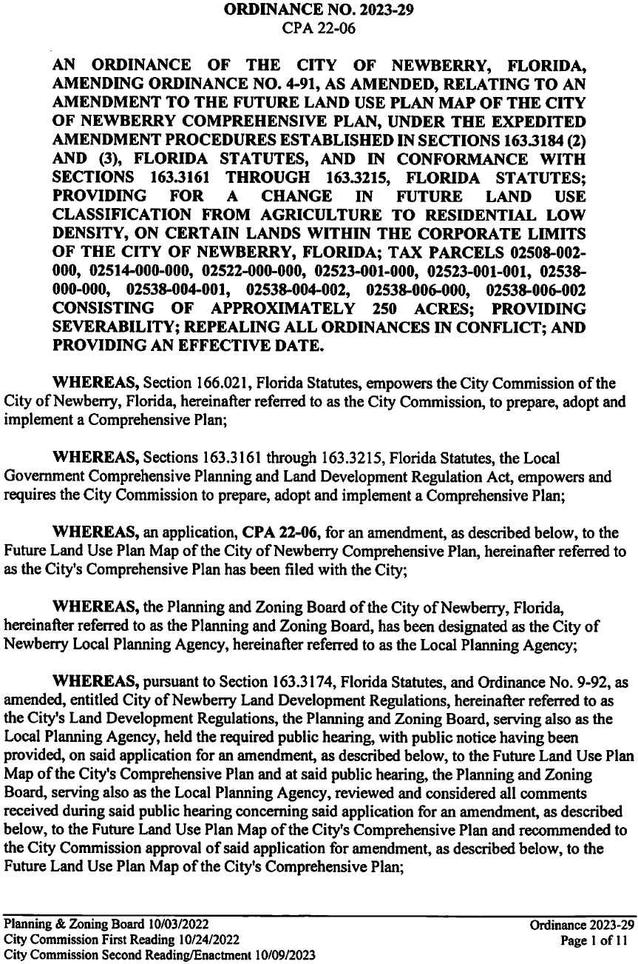

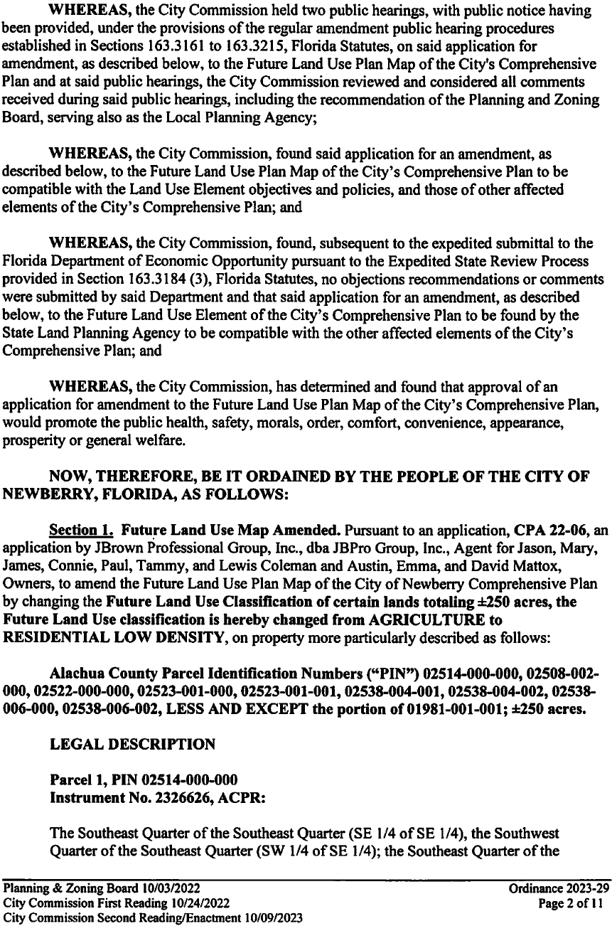

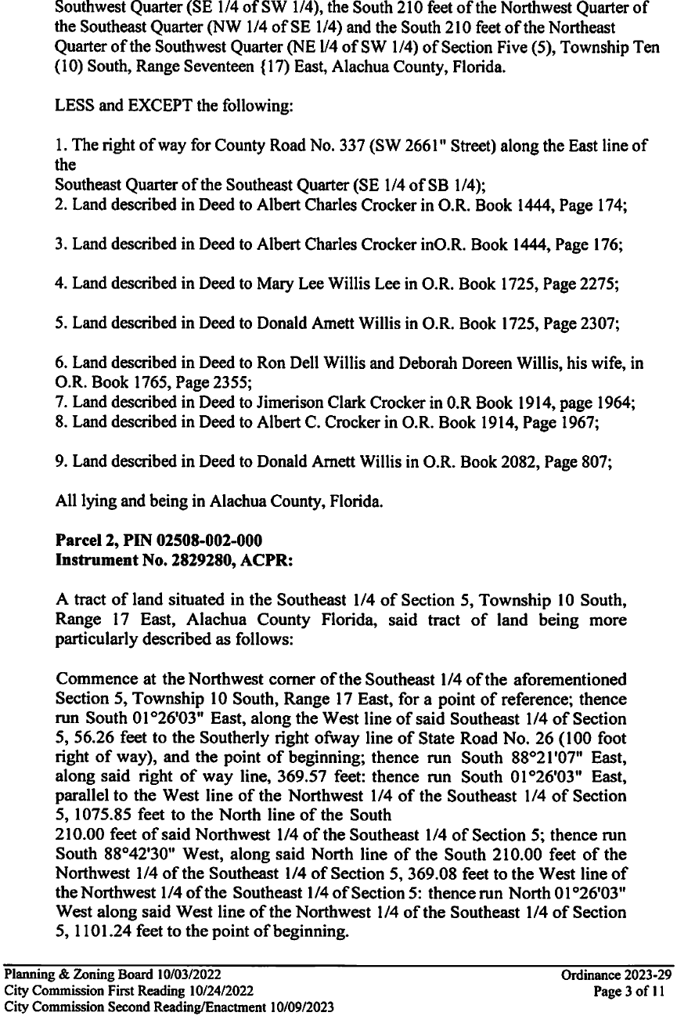

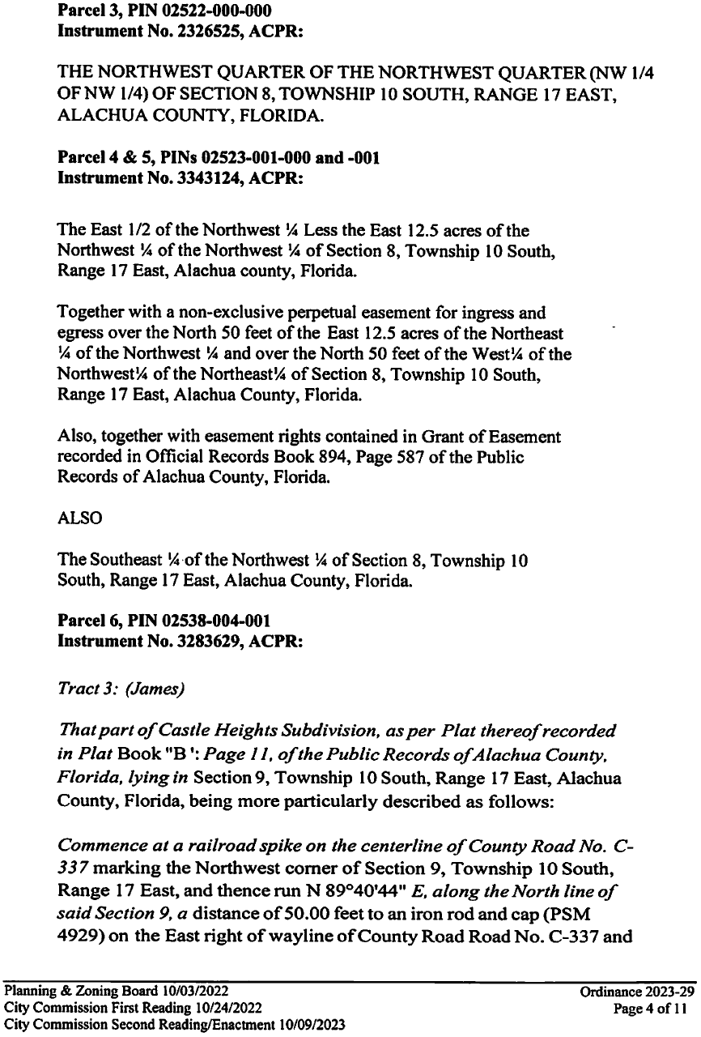
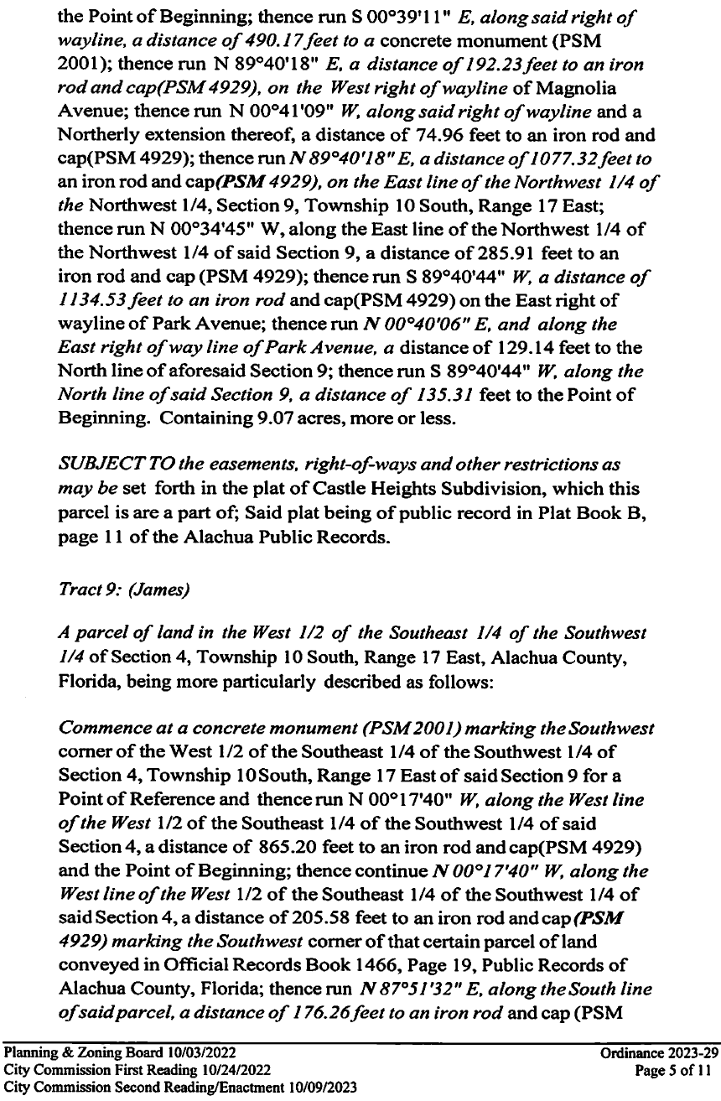
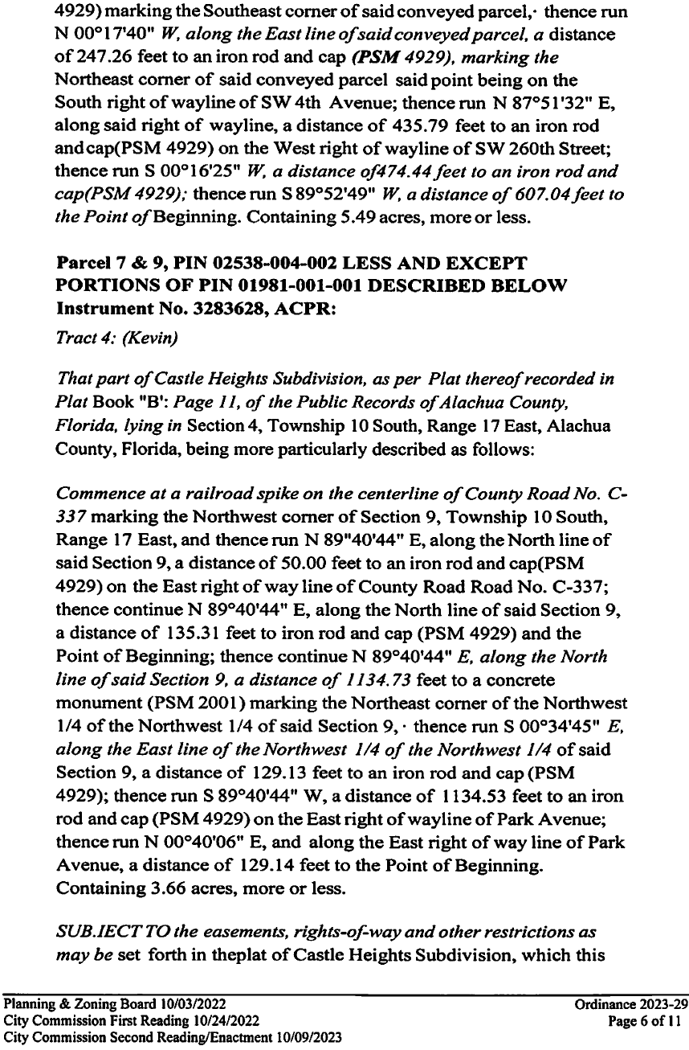

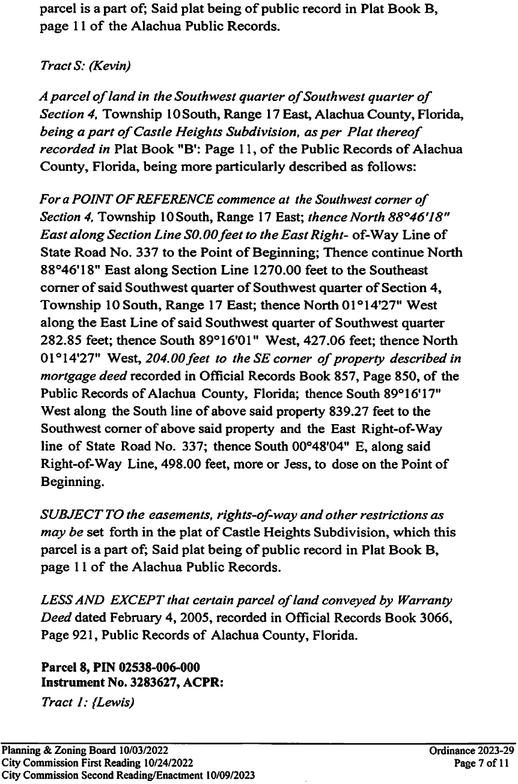

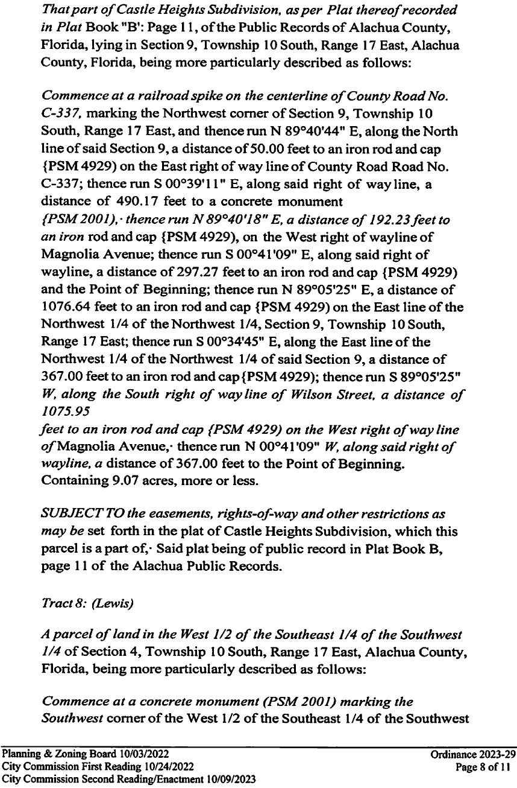

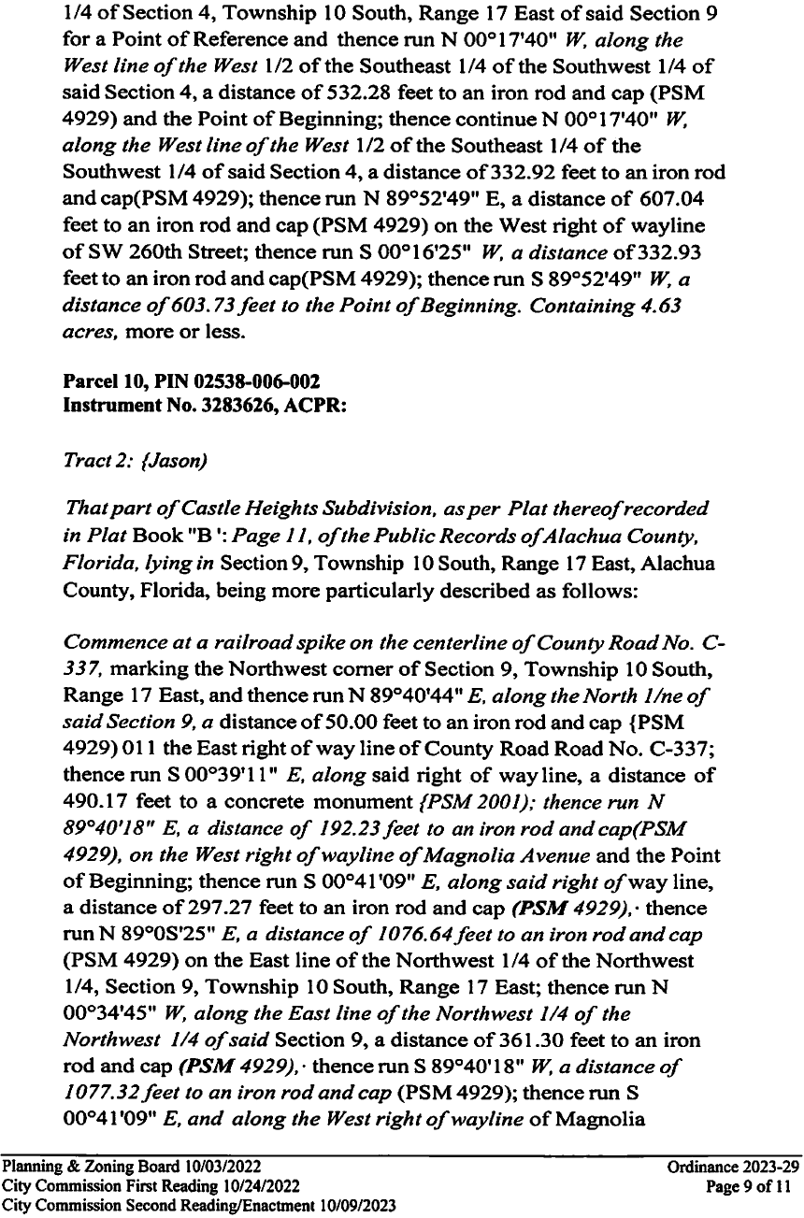

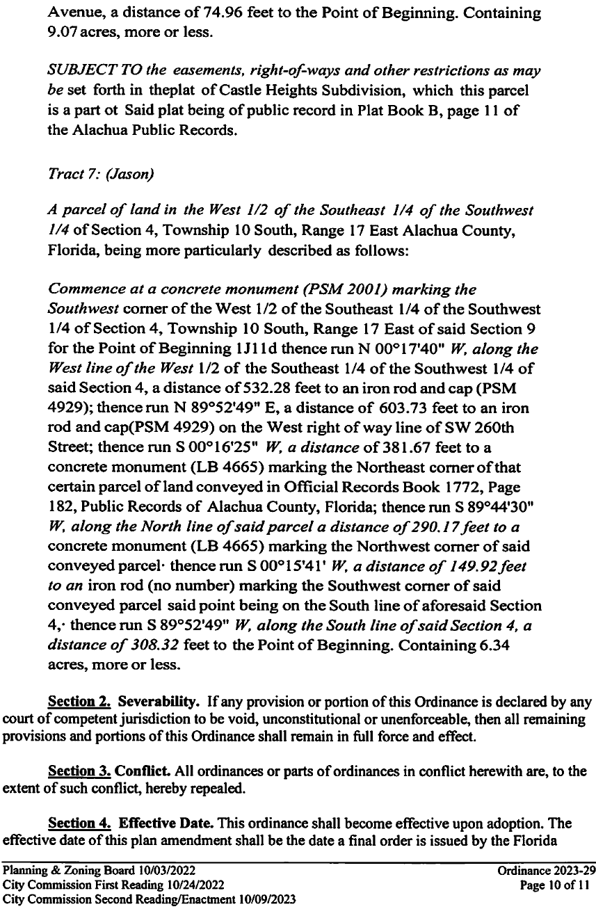

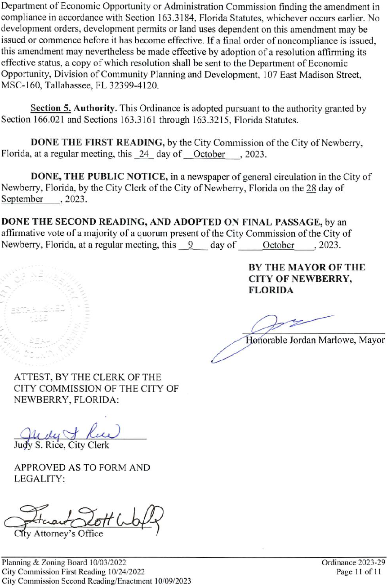

EXHIBIT “C”
FDOC NO OBJECTION LETTER
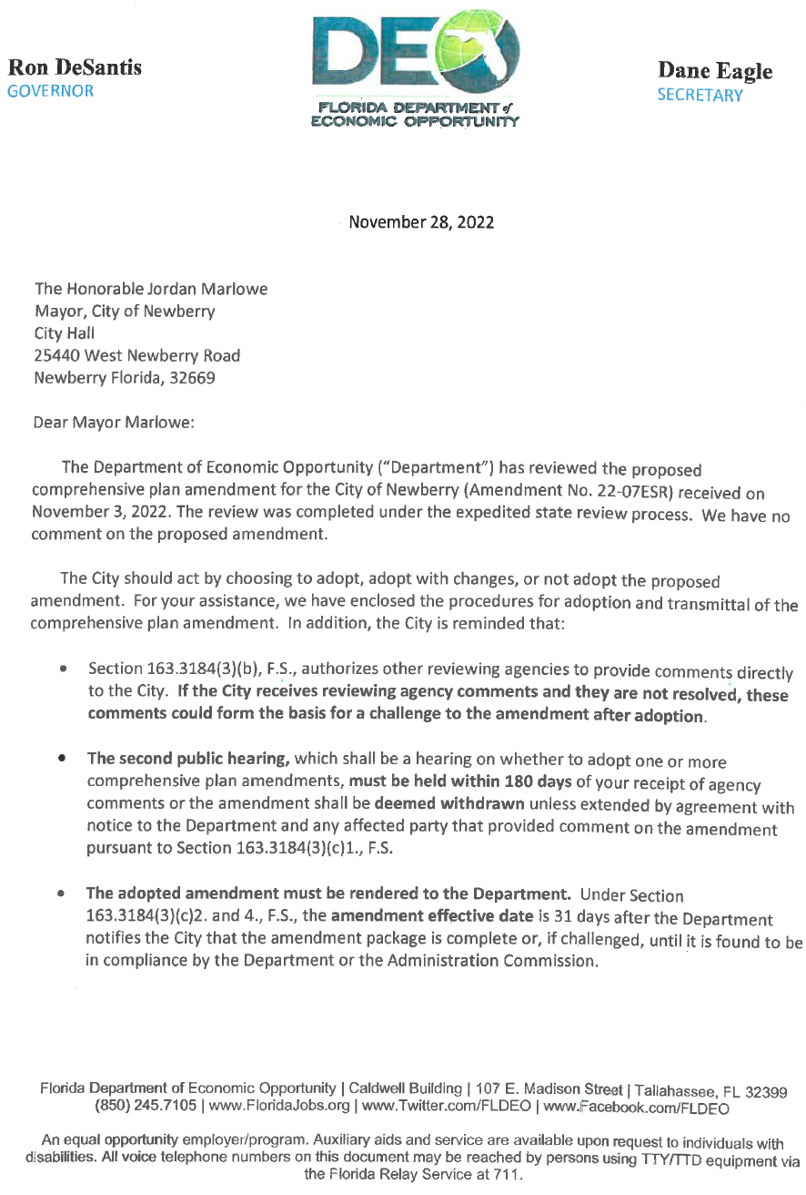
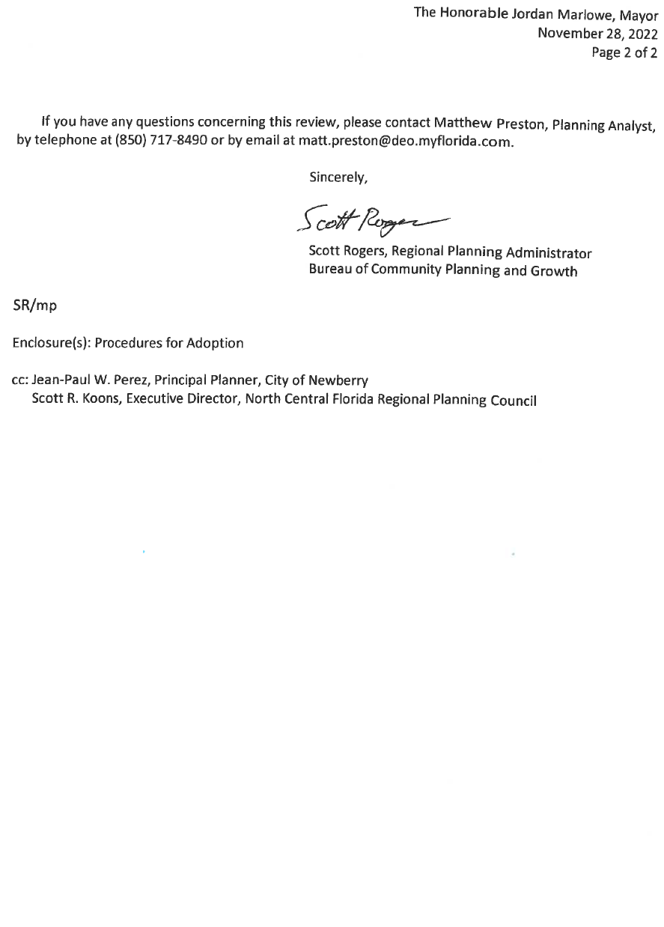

EXHIBIT “D”
FDOC EXTENSION LETTER TO TRANSMIT UPON READOPTION

