ORDINANCE NO. 2025-01
LDR 24-27

AN ORDINANCE OF THE CITY OF NEWBERRY, FLORIDA, ESTABLISHING THE HIGHLAND PARK COMMUNITY DEVELOPMENT DISTRICT PURSUANT TO CHAPTER 190, FLORIDA STATUTES; PROVIDING FOR THE DISTRICT’S EXTERNAL BOUNDARIES; PROVIDING FOR FUNCTIONS AND POWERS OF THE DISTRICT; PROVIDING FOR THE INITIAL BOARD OF SUPERVISORS OF THE DISTRICT; ADDRESSING CORRECTION OF SCRIVENER’S ERRORS; ACKNOWLEDGING THE ADDITIONAL PARCELS IDENTIFIED IN THE PETITION FOR FOR A FUTURE EXPEDITED BOUNDARY AMENDMENT PURSUANT TO §190.046(1)(h)(1), FLA. STAT.; PROVIDING FOR SEVERABILITY AND AN EFFECTIVE DATE.

WHEREAS, Newberry Plaza, LLC (“Petitioner”) has petitioned the City Commission for the City of Newberry, Florida (“City”) to adopt an ordinance establishing Highland Park Community Development District (“District”) pursuant to Chapter 190, Florida Statutes, and granting certain special powers; and

WHEREAS, the City, in determining whether to establish the District boundaries, has considered and finds that:

- All statements contained within the Petition to Establish The Ranch Community Development District (“Petition”) are true and correct;

- The establishment of the District is not inconsistent with any applicable element or portion of the state comprehensive plan or of the effective local government comprehensive plan;

- The area of land within the District is of sufficient size, is sufficiently compact, and is sufficiently contiguous to be developable as one functional interrelated community;

- The District is the best alternative available for delivering community development services and facilities to the area that will be served by the District;

- The community development services and facilities of the District will be compatible with the capacity and uses of existing local and regional community development services and facilities; and

- The area that will be served by the District is amenable to separate special-district government;

WHEREAS, the City has held a public hearing on the Petition in accordance with the requirements and procedures of Sections 190.005(1)(d) and (2)(b), Fla. Stat.; and

WHEREAS, the City has considered the record of the public hearing and the factors set forth in Sections 190.005(1)(e) and (2)(c), Fla. Stat.

WHEREAS, the Petitioner has included within its Petition two (2) additional parcels that the Petitioner anticipates will be added to the District’s boundary in the future as provided by Section 190.046(1)(h), Florida Statutes (2024) (“Additional Parcels”); and

WHEREAS, the City finds that the Petitioner has sufficiently invoked the provisions of Section 190.046(1)(h), Florida Statutes (2024), and is entitled to the expedited boundary amendment process set forth in Section 190.046(1)(h)(1), Florida Statutes (2024), should the District or Petitioner seek to add the Additional Parcels to the District boundary in the future.

NOW THEREFORE, BE IT ORDAINED BY THE PEOPLE OF THE CITY OF NEWBERRY, FLORIDA, THAT:

SECTION 1: AUTHORITY. This ordinance is adopted in compliance with and pursuant to the Uniform Community Development Act of 1980, Chapter 190, Florida Statutes (2024).

SECTION 2: DISTRICT NAME. There is hereby created a community development district situated entirely within incorporated Newberry, Florida, which District shall be known as “Highland Park Community Development District.”

SECTION 3: EXTERNAL BOUNDARIES OF THE DISTRICT. The external boundaries of the District are described in Exhibit A attached hereto.

SECTION 4: FUNCTIONS AND POWERS. The powers and functions of the District are described in Chapter 190, Florida Statutes (2024), as may be amended from time to time. The Charter of the District shall be as set forth in Chapter 190, Florida Statutes, as created by general law. Pursuant to Section 190.012(2)(a) and (2)(d), Florida Statutes (2024), and without intending to limit the same, the District’s Board of Supervisors may further exercise certain additional powers to finance, fund, plan, establish, acquire, construct, reconstruct, enlarge or extend, equip, operate and maintain systems and facilities for (a) parks and facilities for indoor and outdoor recreational, cultural, and educational uses; and (b) security, including but not limited to, guardhouses, fences and gates, electronic intrusion-detection systems, and patrol cars, when authorized by applicable governmental agencies; except that the District may not exercise any police power, but may contract with the City for an increased level of such services within the proposed District boundaries, all as authorized and described by Section 190.012(2)(d), Florida Statutes.

SECTION 5: BOARD OF SUPERVISORS. The five persons designated to serve as initial members of the District’s Board of Supervisors are Thomas Miles, Lois Livingston, Jose Moreno, Charlie Cheston, and Daniel Chandler. All of the listed persons are residents of the State of Florida and citizens of the United States of America.

SECTION 6. CONDITIONS OF APPROVAL. The City Commission of the City of Newberry,
Florida, finds the proposed community development district approvable under the following conditions
which have been accepted by the owner: that pursuant to Florida Statute 190.016(15), default on bonds or
obligations of a district shall not constitute or obligation of local general-purpose government, in this case,
the City of Newberry, Florida, or the state.

SECTION 7. Scrivener’s Errors. The correction of typographical and/or scrivener’s errors which do not affect the intent of the Ordinance may be authorized by the City Manager or designee, without public hearing, by filing a corrected or recodified copy of same with the City Clerk.

SECTION 8. SEVERABILITY. If any provision of this Ordinance, or the application thereof, is finally determined by a court of competent jurisdiction to be invalid, illegal or unenforceable, such provision shall be deemed to be severable and the remaining provisions shall continue in full force and effect.

SECTION 9. EFFECTIVE DATE. This Ordinance shall take effect upon its passage and adoption at the second and final reading.

DONE THE FIRST READING, by the City Commission of the City of Newberry, Florida, at a regular meeting this ____ day of __________, 2025.

DONE, THE PUBLIC NOTICES, in a newspaper of general circulation in the City of Newberry, Florida, by the Petitioner, commencing the ____ day of ____________, 2025, and running once each week for four consecutive weeks, ending on the _____ day of ___________, 2025.

DONE THE SECOND READING, AND ADOPTED ON FINAL PASSAGE, by an affirmative vote of a majority of a quorum present of the City Commission of the City of Newberry, Florida, at a regular meeting this _____ day of _____________, 2025.

BY THE MAYOR OF THE CITY OF NEWBERRY, FLORIDA

_______________________________
Honorable Jordan Marlowe, Mayor

ATTEST, BY THE CLERK OF THE CITY
COMMISSION OF THE CITY OF
NEWBERRY, FLORIDA:

_____________________________
Judy S. Rice, City Clerk

APPROVED AS TO FORM AND
LEGALITY:

___________________________
City Attorney’s Office

EXHIBIT A

DISTRICT BOUNDARY MAP

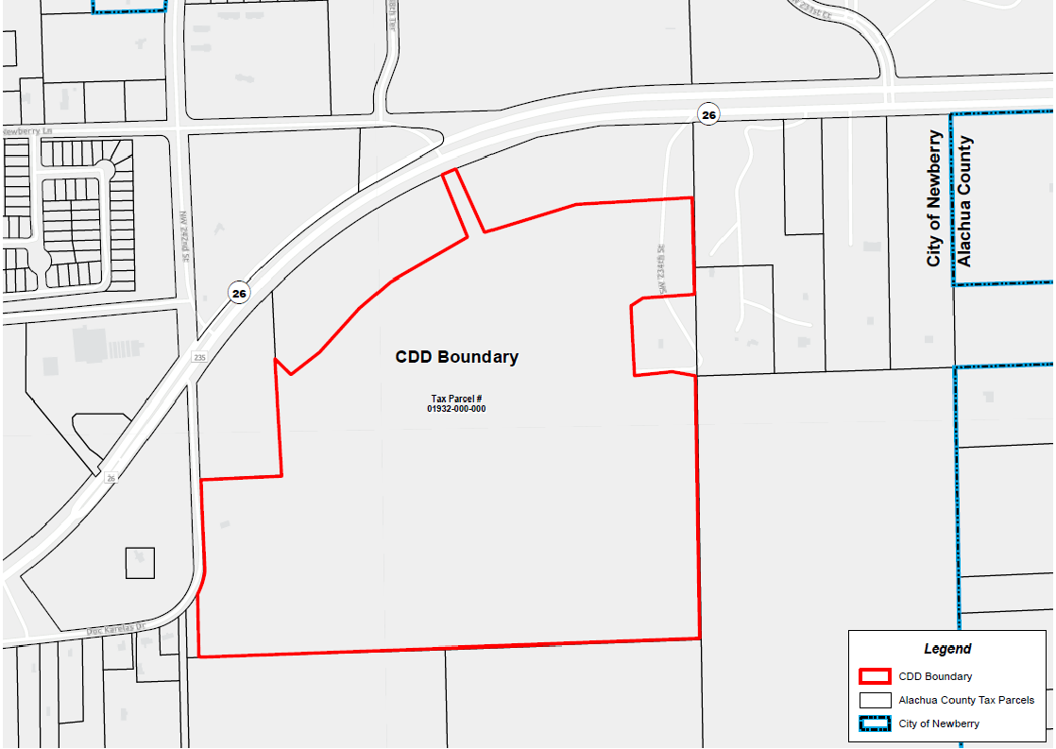

EXHIBIT A CONTINUED
DISTRICT BOUNDARY LEGAL DESCRIPTION

A PARCEL OF LAND SITUATED IN SECTION 3, TOWNSHIP 10 SOUTH, RANGE 17 EAST, ALACHUA COUNTY, FLORIDA, AND BEING MORE PARTICULARLY DESCRIBED AS FOLLOWS:

COMMENCE AT THE NORTHEAST CORNER OF SAID SECTION 3, TOWNSHIP 10 SOUTH. RANGE 17 EAST, THENCE RUN SOUTH 00°55'07" EAST, ALONG THE EAST LINE OF SAID SECTION 3, A DISTANCE OF 49.79 FEET TO A POINT ON THE SOUTH RIGHT OF WAY LINE OF STATE ROAD NO. 26, ALSO KNOW AS WEST NEWBERRY ROAD (RIGHT OF WAY WIDTH VARIES); THENCE CONTINUE SOUTH 00°55'07" EAST, ALONG SAID EAST LINE OF SECTION 3, A DISTANCE OF 390.04 FEET; THENCE RUN SOUTH 88°13'33" WEST, A DISTANCE OF 40.00 FEET TO THE POINT OF BEGINNING; THENCE RUN SOUTH 00°55'07" EAST, A DISTANCE OF 500.05 FEET; THENCE RUN SOUTH 89°04'53" WEST, A DISTANCE OF 232.77 FEET; THENCE RUN SOUTH 66°55'59" WEST, A DISTANCE OF 110.00 FEET; THENCE RUN SOUTH 23°04'01" EAST, A DISTANCE OF 393.61 FEET TO THE BEGINNING OF A CURVE CONCAVE TO THE SOUTHWEST, HAVING A RADIUS OF 80.00 FEET AND BEING SUBTENDED BY A CHORD HAVING A BEARING AND DISTANCE OF SOUTH 20°13'55" EAST, 7.91 FEET; THENCE RUN SOUTHEASTERLY ALONG THE ARC OF SAID CURVE, THROUGH A CENTRAL ANGLE OF 05°40'14", AN ARC LENGTH OF 7.92 FEET TO THE END OF SAID CURVE; THENCE RUN NORTH 72°36'12" EAST, A DISTANCE OF 110.00 FEET TO THE BEGINNING OF A CURVE
CONCAVE TO THE WEST, HAVING A RADIUS 190.00 FEET AND BEING SUBTENDED BY A CHORD HAVING A BEARING AND DISTANCE OF SOUTH 16°36'49" EAST, 5.19 FEET; THENCE RUN SOUTHEASTERLY ALONG THE ARC OF SAID CURVE, THROUGH A CENTRAL ANGLE OF 01°33'58", AN ARC LENGTH OF 5.19 FEET TO THE END OF SAID CURVE; THENCE RUN NORTH 89°04'53" EAST, A DISTANCE OF 76.75 FEET; THENCE RUN SOUTH 00°54'31" EAST, A DISTANCE OF 1366.55 FEET TO THE SOUTH LINE OF THE NORTHEAST 1/4 OF SAID SECTION 3; THENCE RUN SOUTH 88°01'08" WEST, ALONG SAID SOUTH LINE, A DISTANCE OF 2527.72 FEET; THENCE RUN NORTH 01°08'19" WEST, A DISTANCE OF 323.21 FEET TO THE BEGINNING OF A CURVE CONCAVE TO THE NORTHWEST, HAVING A RADIUS OF 383.00 FEET AND BEING SUBTENDED BY A CHORD HAVING A BEARING AND DISTANCE OF NORTH 17°49'26" EAST, 123.81 FEET; THENCE RUN NORTHEASTERLY ALONG THE ARC OF SAID CURVE, THROUGH A CENTRAL ANGLE 18°36'14", AN ARC LENGTH OF 124.36 FEET TO THE END OF SAID CURVE; THENCE RUN NORTH 02°44'03" WEST, A DISTANCE OF 482.45 FEET; THENCE RUN NORTH 87°18'09" EAST 393.72 FEET; THENCE RUN NORTH 02°41'15" WEST, A DISTANCE OF 559.34 FEET; THENCE RUN SOUTH 51°07'16" EAST, A DISTANCE OF 107.68 FEET TO THE BEGINNING OF A CURVE CONCAVE TO THE SOUTHEAST, HAVING A RADIUS OF 2424.79 FEET AND BEING SUBTENDED BY A CHORD HAVING A BEARING AND DISTANCE OF NORTH 52°26'00" EAST, 1136.59 FEET; THENCE RUN NORTHEASTERLY ALONG THE ARC OF SAID CURVE, THROUGH A CENTRAL ANGLE OF 27°06'32", AN ARC LENGTH OF 1147.26 FEET TO THE END OF SAID CURVE; THENCE RUN NORTH 23°04'01" WEST, A DISTANCE OF 390.05 FEET TO A POINT ON THE SOUTH RIGHT OF WAY LINE OF STATE ROAD NO. 26, ALSO KNOW AS WEST NEWBERRY ROAD (RIGHT OF WAY WIDTH VARIES) AND THE BEGINNING OF A CURVE CONCAVE TO THE SOUTHEAST, HAVING A RADIUS OF 2814.79 FEET AND

EXHIBIT A CONTINUED
LEGAL DESCRIPTION

BEING SUBTENDED BY A CHORD HAVING A BEARING AND DISTANCE OF NORTH 66°55'59" EAST, 80.00 FEET; THENCE RUN NORTHEASTERLY ALONG THE ARC OF SAID CURVE, THROUGH A CENTRAL ANGLE OF 01°37'43", AN ARC LENGTH OF 80.00 FEET TO THE END OF SAID CURVE; THENCE RUN SOUTH 23°04'01" EAST, A DISTANCE OF 390.05 FEET TO THE BEGINNING OF A CURVE CONCAVE TO THE SOUTHEAST, HAVING A RADIUS OF 2424.79 FEET AND BEING SUBTENDED BY A CHORD HAVING A BEARING AND DISTANCE OF NORTH 78°03'07" EAST, 856.60 FEET; THENCE RUN NORTHEASTERLY ALONG THE ARC OF SAID CURVE, THROUGH A CENTRAL ANGLE OF 20°20'51", AN ARC LENGTH OF 861.12 FEET TO THE END OF SAID CURVE; THENCE RUN NORTH 88°13'33" EAST, A DISTANCE OF 218.51 FEET TO THE POINT OF BEGINNING. THE ABOVE DESCRIBED LANDS CONTAINS 104.245 ACRES, MORE OR LESS.

